**R.E. Branch 3; Galilee to Jerusalem**

- Epiphany

- The presentation of Jesus at the temple

- Jesus’ ministry and the Word of God; he came to show God’s love and welcome everyone. How can we share God’s love too?

- Pray ‘The Glory Be’

*Throughout this half term, children will hear about Jesus’ life and ministry through parables, encounters and miracles*

**Personal, Social and Emotional Development & HRSE**

- valuing difference; similarities and differences between ourselves and others

Celebrating difference

- showing kindness

- safer internet week

*School value – be loving*

’

**Physical Development**

**GM** - Continue to develop fundamental movement skills

- learn to negotiate space and develop coordination, balance and agility when using mats, climbing and balancing apparatus (Lancs PE passport)

**FM** - Continue to develop correct use of pencils, scissors, cutlery etc. Encourage correct posture, grip and control. Develop letter formation and orientation. Malleable play & threading skills

**Expressive Arts and Design**

- continue to develop art and craft skills eg colour mixing, brush control, use of scissors and joining techniques, construction kits. Create with purpose, talking about ideas and processes involved

- malleable play; playdough, clay

- imaginative play with a bear theme – Three Bears Cottage, Teddy Bears Picnic, Zoo and Artic small world

- explore texture through different fabrics and materials

- develop simple sewing skills; sock bear puppet!

- Extend repertoire of songs to include topic related ones

- continued exploration of percussion instruments

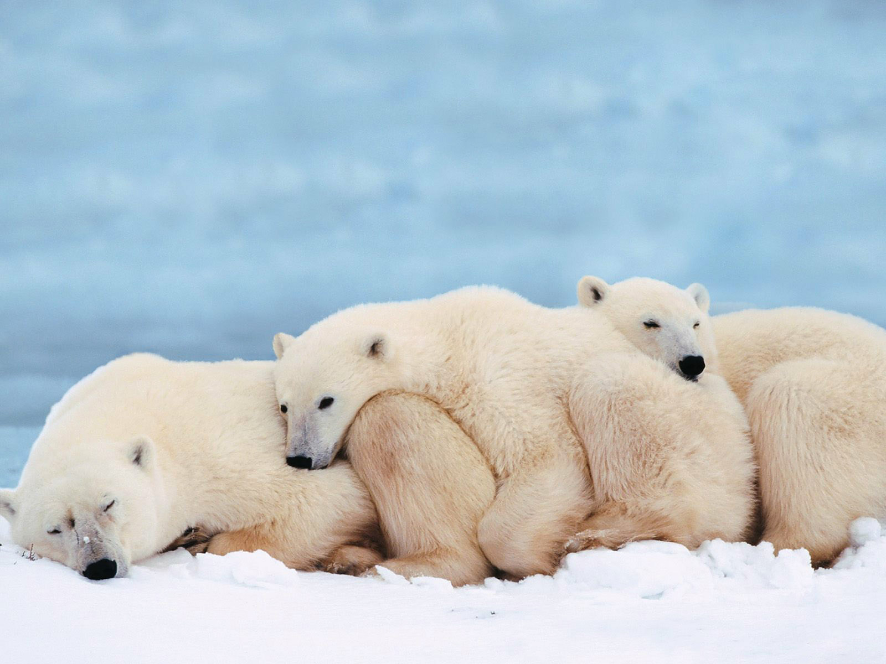

**Communication and Language**

- further develop active listening skills; promote and model

- listen to and talk about stories and their sequence

- retell stories using T4W eg. Goldilocks and the Three Bears

- develop language and vocabulary through story telling

- maximise opportunities to develop narrative skills through small world and imaginative play in relation to topic eg Three Bears Cottage role play

- learn and use new vocab in different contexts inc new topic vocab

- listen and talk about non-fiction books in relation to topic. Ask open questions to find out more information and listen carefully to answers

-

**WRENS YR**

***BEARS***

**Spring 1 2025**

**Mathematics**

- introduce zero

- find, subitise & represent numbers 0-5

Composition of 0-5

-1 more/1 less

- find & represent 6,7,8

- composition of 6,7,8

Making pairs; odd and even

- find and make doubles

Combining groups

Exploring 3D shapes

**Understanding of the World**

- explore the natural world around them; make observations and talk about what they see

- Explore Winter; compare with other seasons. Observe & interact with ice making/melting, hot/cold temperatures, associated clothing. Begin to understand effect of changing seasons on natural world, including animals

- study different animals and recognise that not all animals are the same. Compare similarities and differences. Learn what animals need to survive

- Chinese New Year; find out about this celebration, eat related food and use utensils, make lanterns etc

**Literacy**

- secure recognition of all individual letters and sounds at PH 2 & 3 (intervention where needed). Blend sounds together to read vc and cvc words

- teach diagraphs at Phase 3 and HFW, inc ‘tricky words’. Practice reading using new words and sounds

- encourage blending and segmenting sounds to help with reading and spelling.

- read and write captions and short sentences with more independence using phonic knowledge to help

- begin to use full stop correctly and finger spaces; with support as appropriate

- orally rehearse a simple sentence and ‘read’ what they’ve written

- form lower-case letters with greater accuracy, using correct tripod grip (intervention where needed)

***Model text; Goldilocks and The Three Bears Supporting texts; other bear stories e.g. We’re Going on a Bear Hunt, This is the Bear, Bumble Bear etc plus quality non-fiction books about animals, weather and seasons***